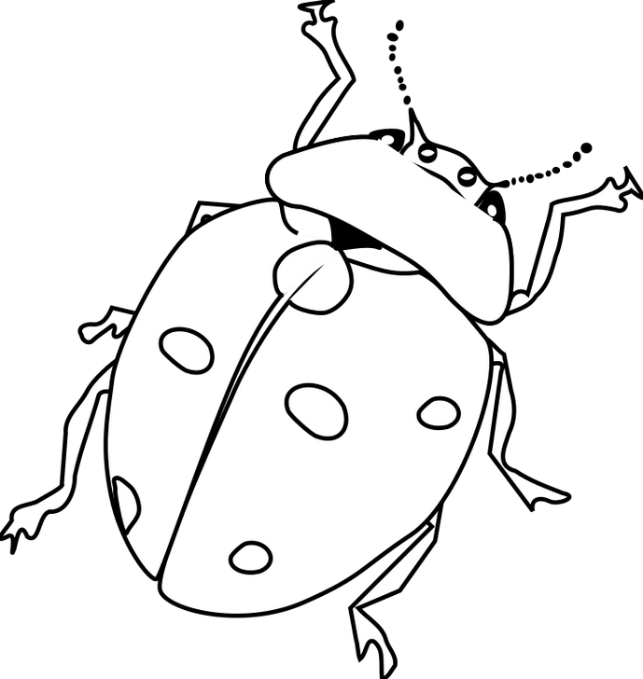

The ladybug is red and black.

T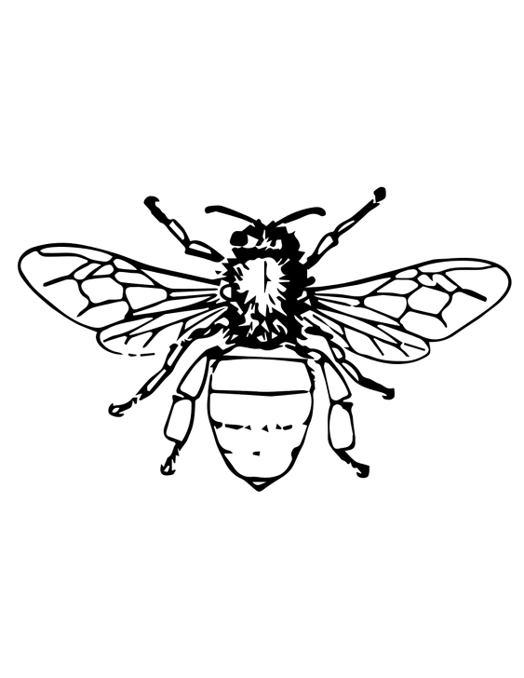

The bee is yellow and black.

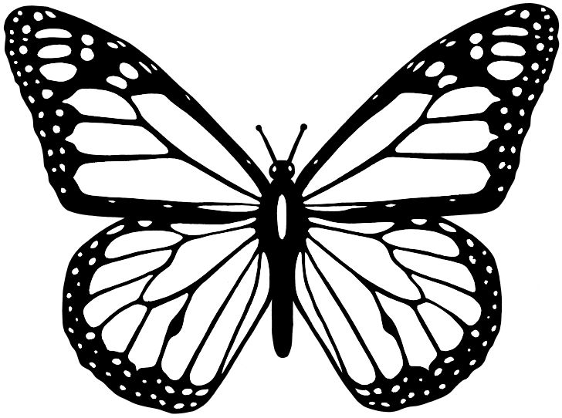

The butterfly is orange and pink and purple.

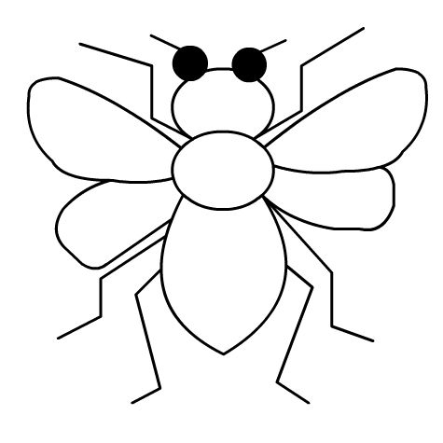

The fly is blue and green.

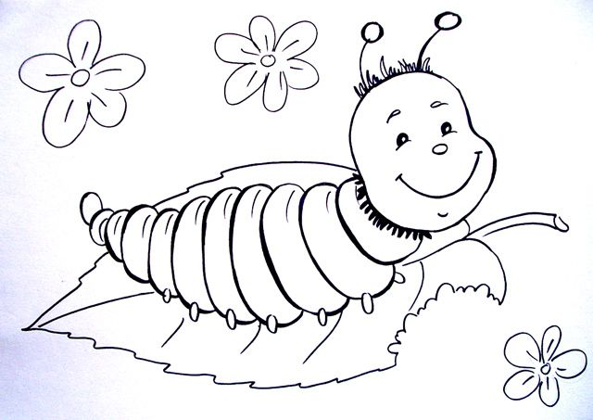

The caterpillar is red and orange and blue.

Colour the paintings and answear these questions:

What colour is ladybug?

How many dots has ladybug got?

How many legs has fly got?

Do you like caterpillars?