ČTENÁŘSKÝ LIST

měsíc: 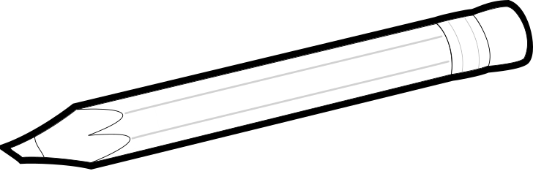 pro 3. třídu

**AUTOR KNIHY**

**MOJE JMÉNO**

**NÁZEV KNIHY**

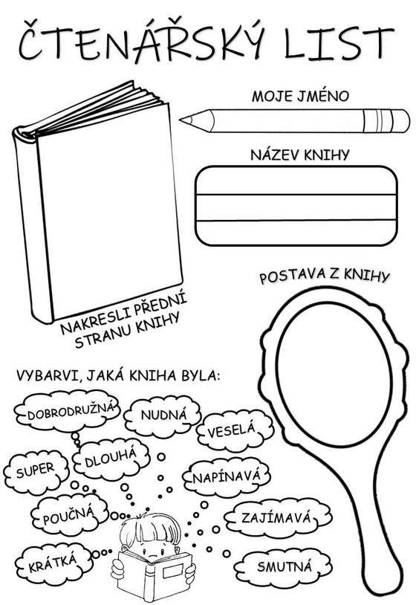





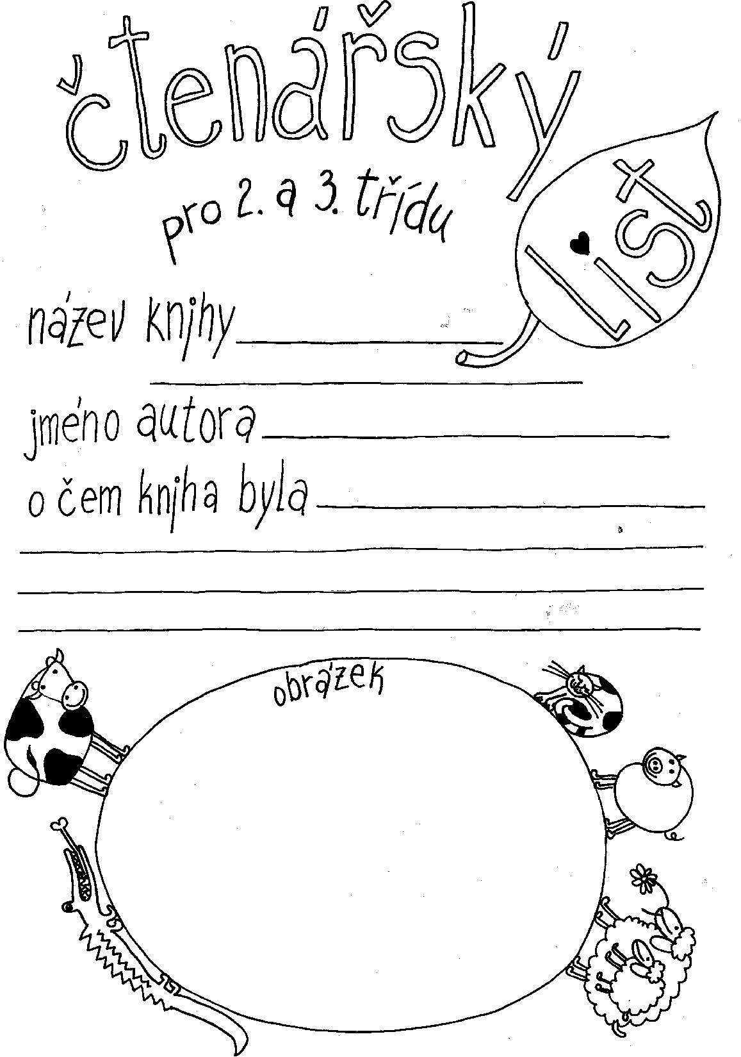

Napiš alespoň pět vět. Máš-li chuť, můžeš i více.

DĚJ KNIHY:

__________________________________________________________________________________________________________________________________________________________________________________________________________________________________________________________________________________________________________________________________________________________________________________________________________________________________________________________________________________________________________________________________________________________________________________________________________________________________________________________________________________________________________________________________________________________________________________________________________________________________________________________________________________________________________________________________________________________________________________________________________________________________________________________________________________________________________________________________________________________________________________________________________________________________________________________________________________________________________________________________________________________________________________________________________________________________________________________________________________________________________________________________________________________________________________________